IFTA News Clearinghouse
What the IFTA Community did in 2020
6,681 Audits were posted in 2020 to the IFTA, Inc. Clearinghouse.
Over 12,000,000 Transmittal details were posted.
You entered the Clearinghouse Transmittals page 24,148 times.
You entered the Clearinghouse Demographics page 56,439 times.
647,948 Demographic carrier records are stored on the Demographics Server.
1,762,576 Webservices hits were recorded on the Demographics Server.
Be sure you get the new 2021 Funds Netting Calendar from the Transmittal Web Site. You can find it on the front page of the Transmittal Web Site.
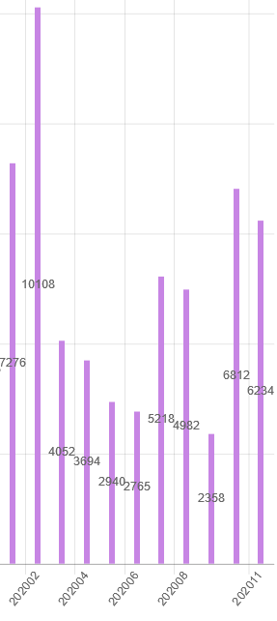
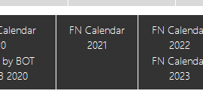
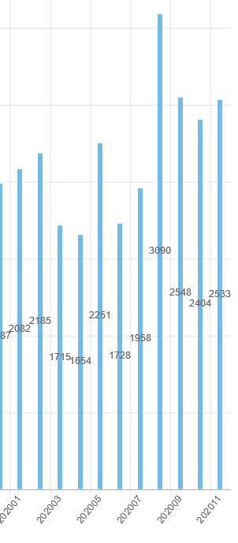
Demographic Hits Transmittal Hits

